Problem Statement:

You work for XYZ Corporation. Your team is asked to deploy similar architecture multiple times for testing, development, and production purposes. Implement CloudFormation for the tasks assigned to you below.

Tasks To Be Performed:

1. Create a FIFO SQS queue and test by sending messages.

#### 2. Register your mail in SES and send a test mail to yourself Create a FIFO SQS queue

#### Step 1: Create the FIFO SQS Queue

1. **Log in to the AWS Management Console**.
2. Navigate to the **Amazon SQS** service.
3. Click on **Create queue**.
4. Choose **FIFO** for the queue type.
5. Enter a name for the queue that ends with .fifo, for example, my-fifo-queue.fifo.
6. Configure the queue settings as needed. Make sure to enable **Content-based deduplication** if you want to deduplicate messages automatically based on their content.

#### Click on Create queue. Step 2: Send a Test Message to the FIFO SQS Queue

1. After the queue is created, go back to the SQS dashboard and select your FIFO queue.
2. Click on the **Queue Actions** button and select **Send and receive messages**.
3. In the **Message body** field, enter your test message, e.g., "This is a test message".
4. For **Message group ID**, enter a value such as testGroup.
5. Click on **Send message**.  
     
     
     
   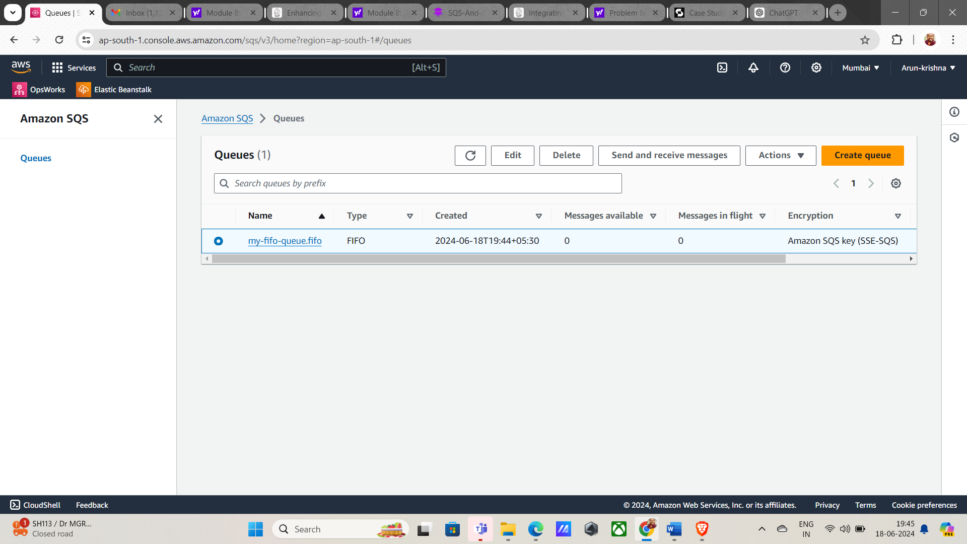

### **Task 2: Register Your Mail in SES and Send a Test Mail**

#### Step 1: Verify Your Email Address in SES

1. **Log in to the AWS Management Console**.
2. Navigate to the **Amazon SES** service.
3. In the left-hand navigation pane, click on **Email Addresses** under the **Identity Management** section.
4. Click on **Verify a New Email Address**.
5. Enter your email address and click on **Verify This Email Address**.
6. Check your email inbox for the verification email from AWS SES and click on the verification link.  
   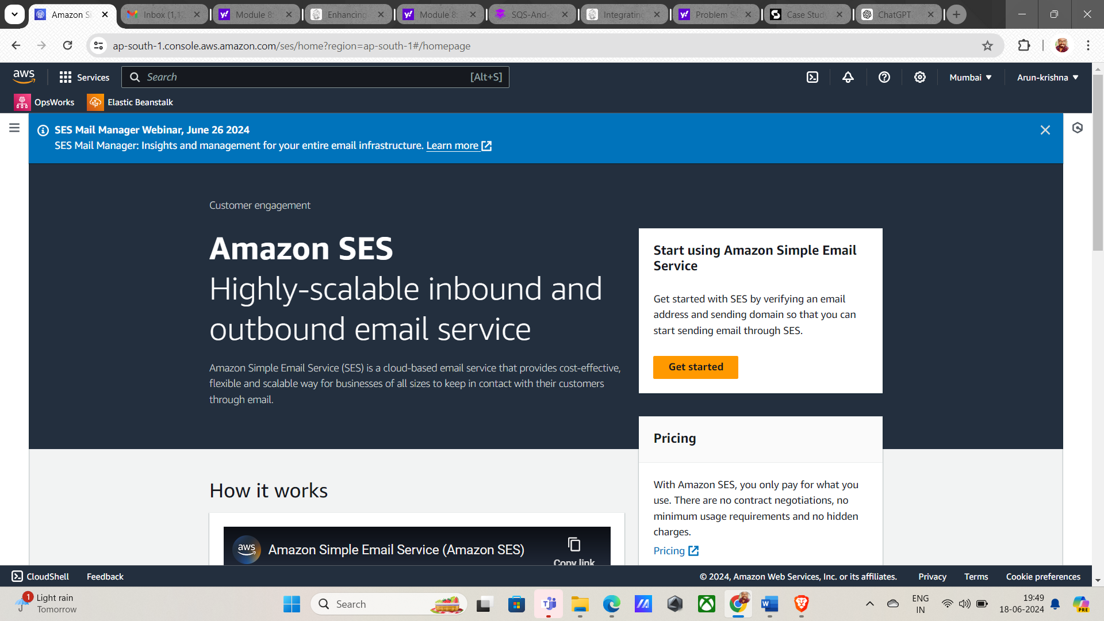  
     
     
   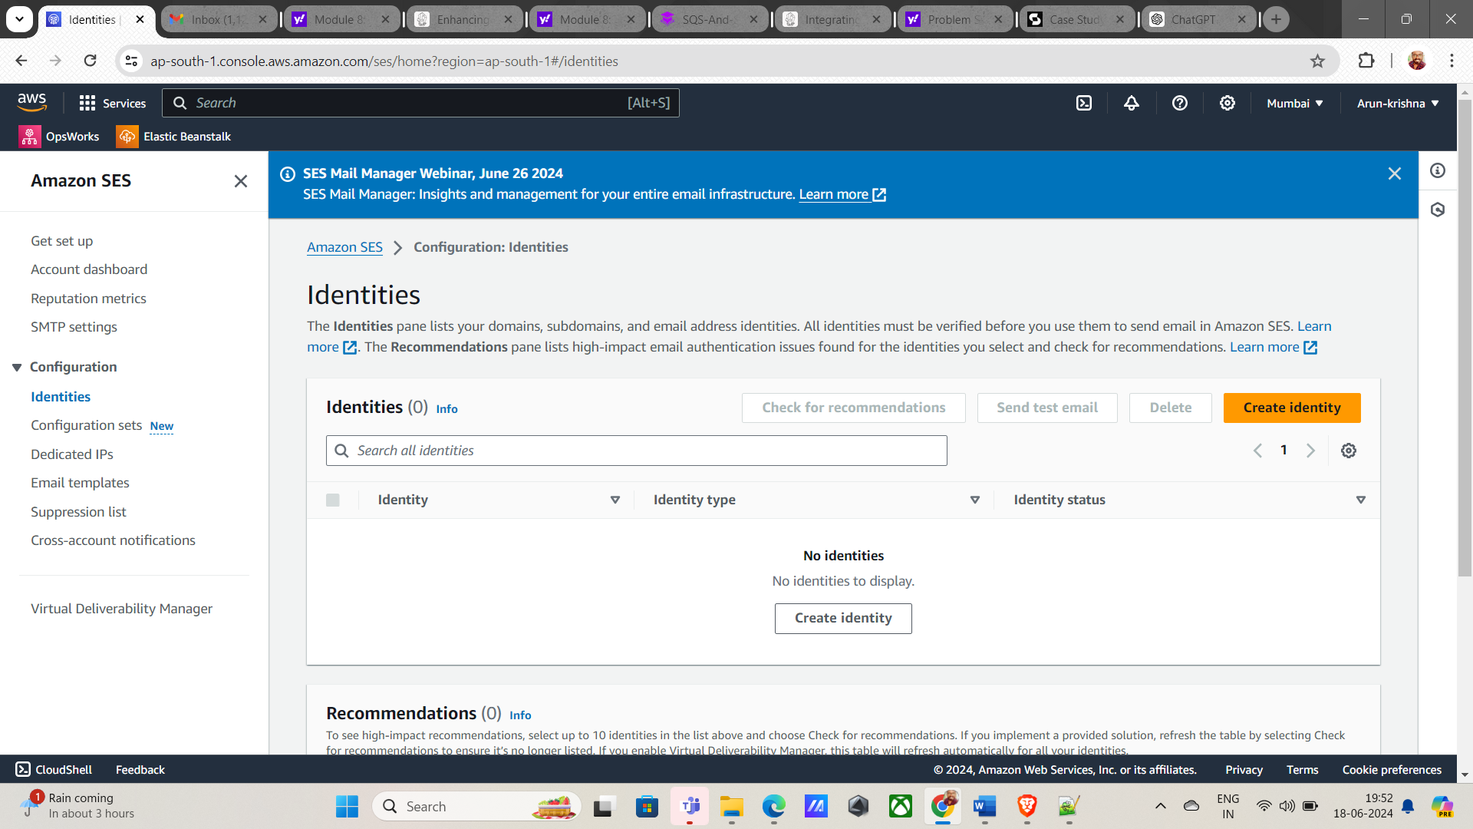  
     
   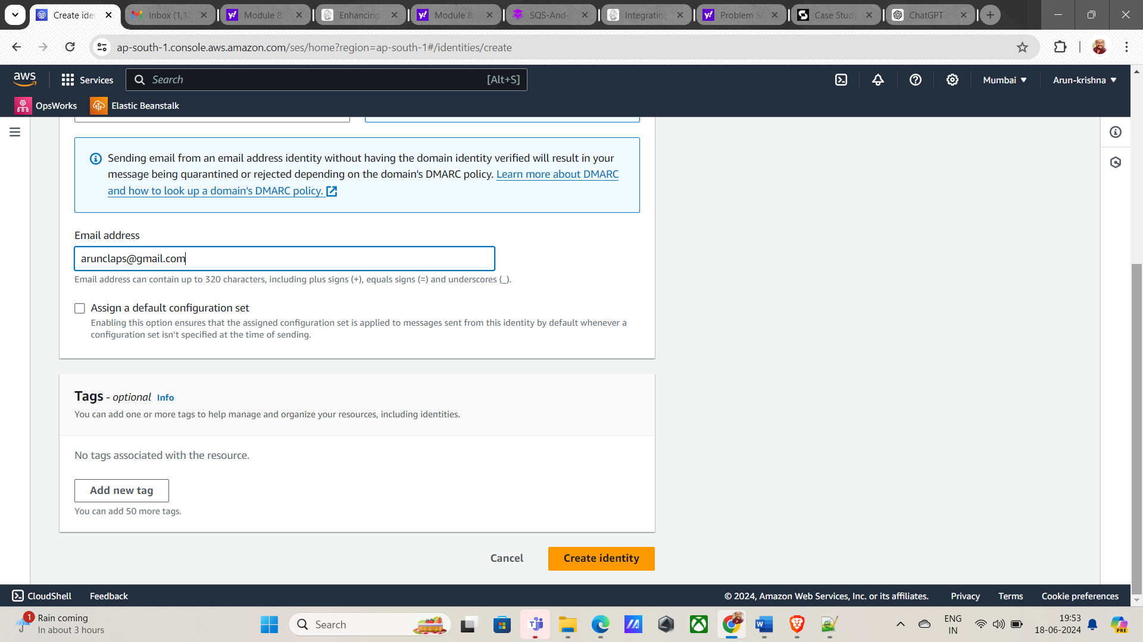  
     
     
     
   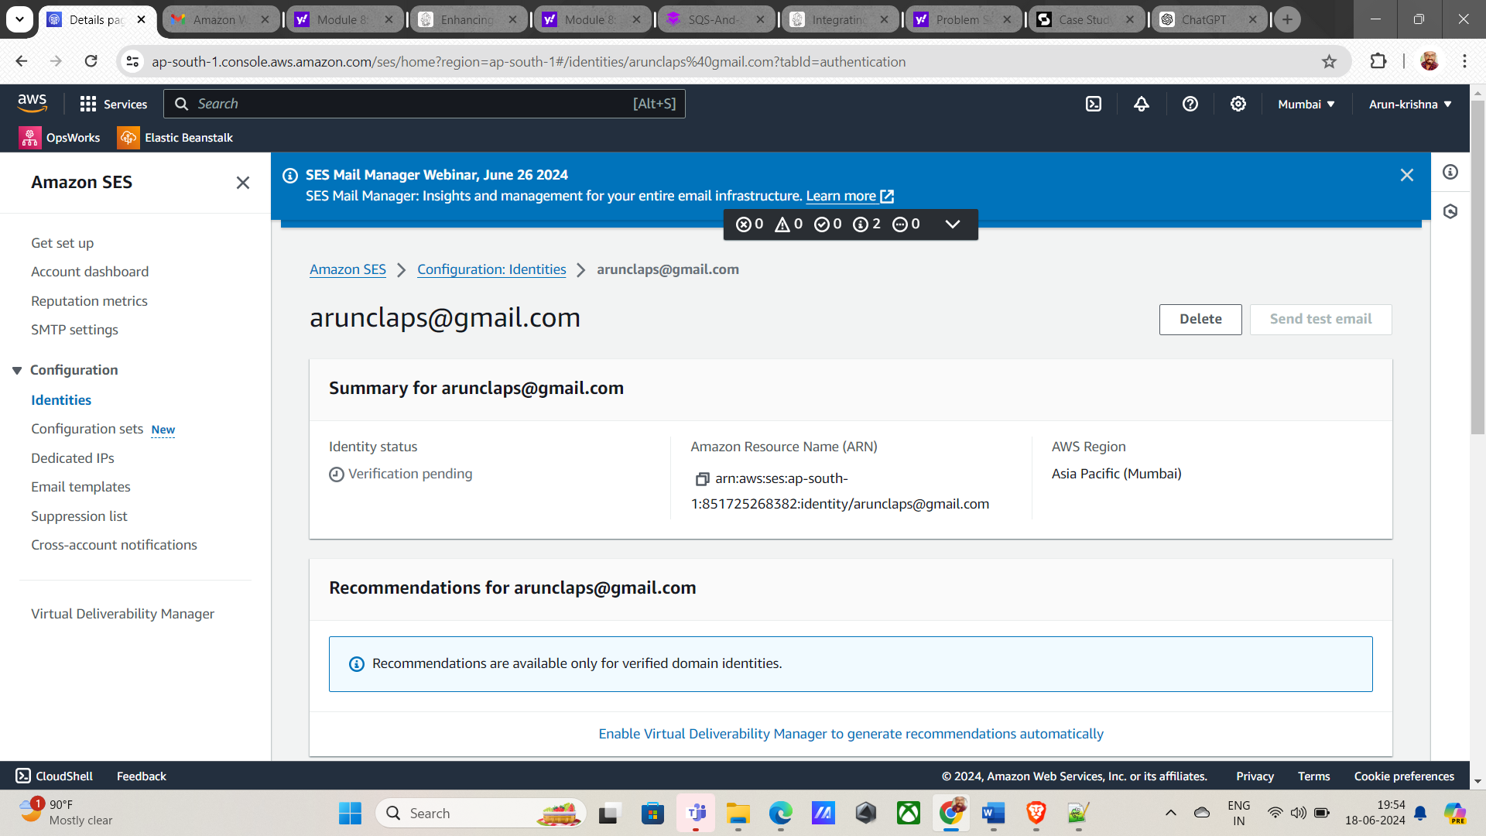  
     
     
     
   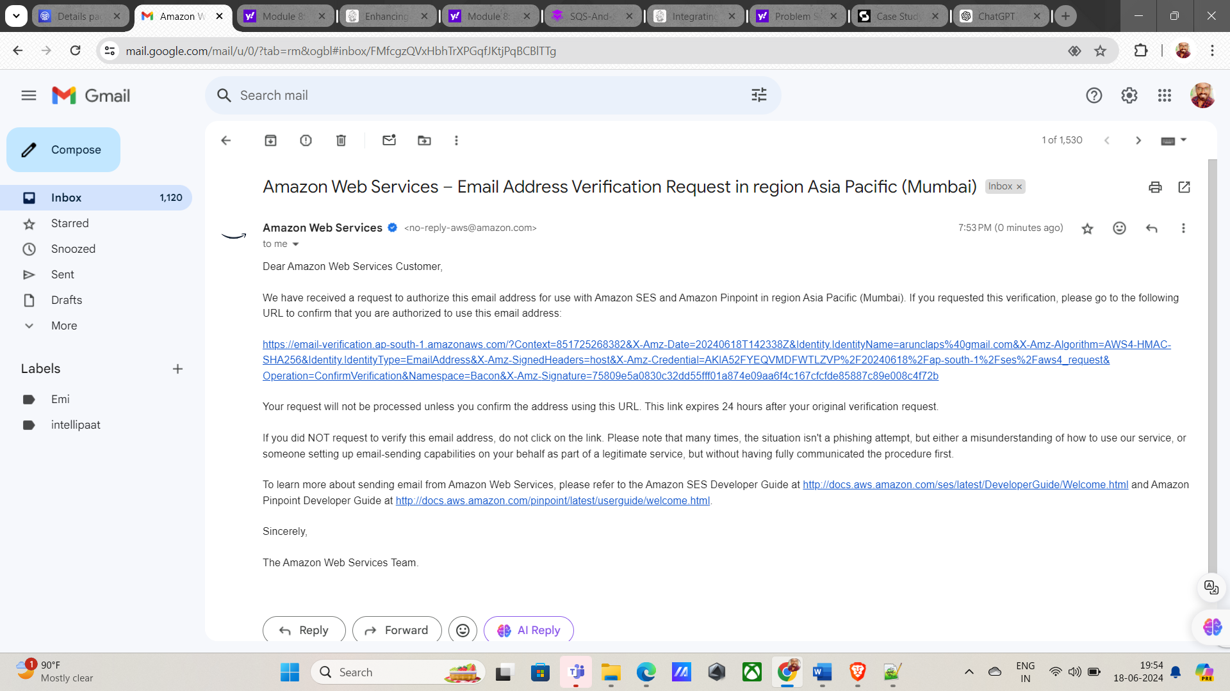  
     
     
     
   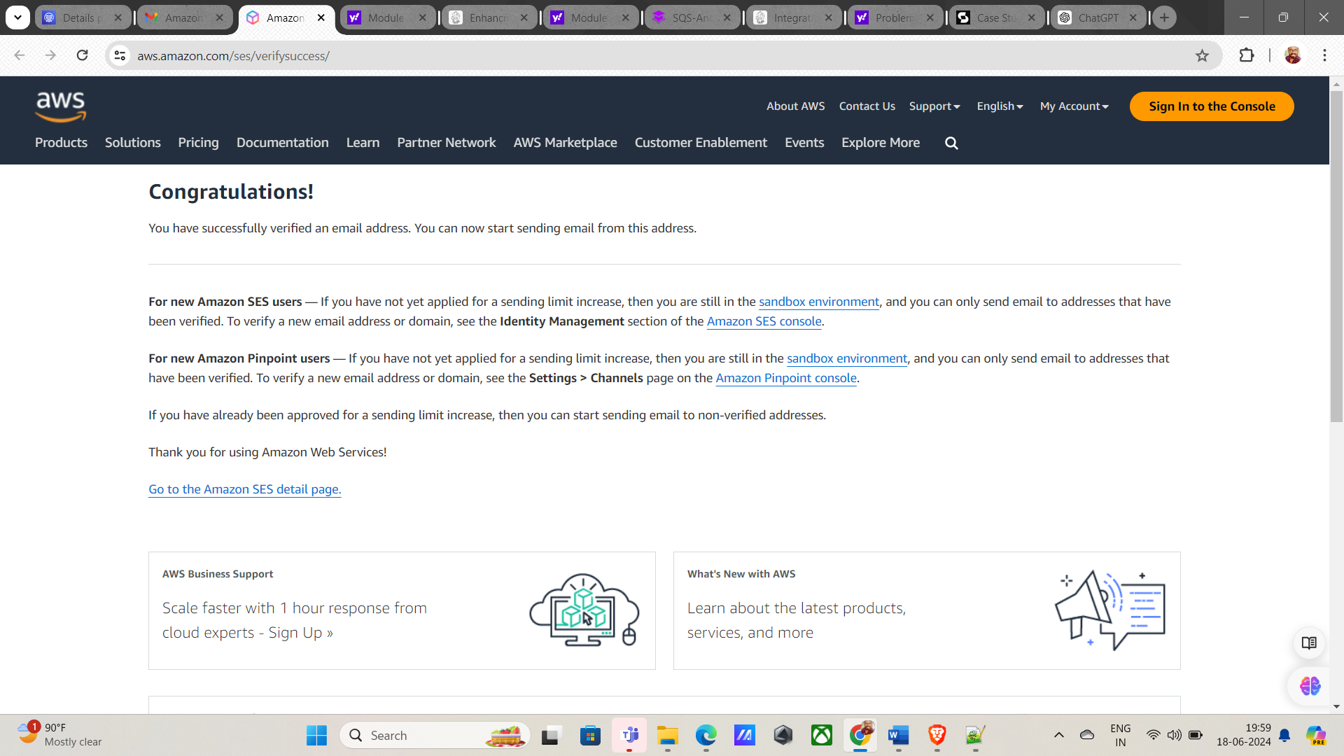  
     
     
   Step 2: Send a Test email using SES

1. Click on Send Test Email.

2. In the Email Address field, enter your verified email address.

3. In the Subject field, enter a subject for your test email, such as "Test Email".

4. In the Body field, enter the content of your test email, such as "This is a test email sent via SES".

5. Click on Send Test Email.

